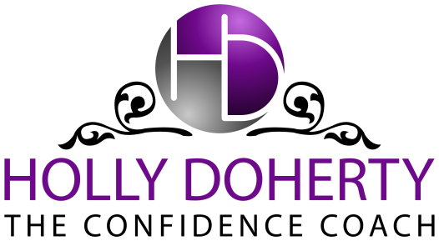

www.hollydoherty.com
SPEAKER INTRO AND TALK SUMMARY
TITLE: The Cornerstone of Confidence: Building a Godly Foundation of Self-Esteem for Success in Life and Business
Special Guest: Holly Doherty, creator of The GOSPEL MethodTM to Love Yourself and Rock Your Business
Do you have big dreams for your business, but secretly doubt that you’re worth it? Join Holly Doherty and discover how to increase your self-esteem without being selfish, love yourself as the amazing masterpiece you were created to be, and gain the confidence to pursue your dreams in a way that honors God and creates the impact on the world you’re meant to have.
In this inspiring session you’ll learn:
- What true self-esteem REALLY means. There are a lot of misconceptions out there.
- 3 secrets to liberate yourself from the guilt and self-doubt that hold you back from going after your dreams.
- How to go beyond superficial affirmations and develop unshakable self-esteem that isn’t dependent on your resume or your accomplishments.

You’re called to live an abundant life. You’re called to be a city on a hill, a shining star. You can’t do that when you’re full of self-doubt, when all you see are your faults, and when you’re afraid to step into your calling and passion for fear of looking prideful or arrogant. You owe it to your clients – and you owe it to God – to love yourself the way He does and to have the confidence to shine brightly as you pursue your dreams. God gave you those dreams. It’s time you had the confidence to go after them.

