Holly Doherty’s Bio
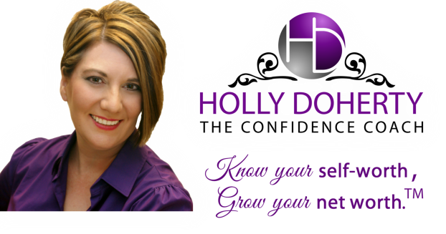
Holly Doherty, the Confidence Coach, works with Christian entrepreneurs who struggle with low self-esteem and are tired of beating themselves up with self-doubt, and who are ready to know their self-worth so they can grow their net worth.
She is the author of several books, including Get Organized This Weekend and The Magic of Family Meals: 115 Conversation Starters to Connect With Your Kids.
Drawing on lessons she learned from her own struggle to restore her self-esteem following more than 20 years of abuse, Holly brings a message of hope and healing that empowers women to understand their God-given worth and to give themselves permission to be wildly successful. Creator of The GOSPEL Method™ to Love Yourself and Rock Your Business, Holly helps women accept themselves for who they are, and have the confidence to stand out and be amazing. Like a modern-day Michelangelo, Holly Doherty helps women chisel away all the bits and pieces of their identity that falsely define them. She helps them discover the unique and beautiful masterpiece that’s within them, and develop unshakable self-esteem so they have the confidence to get their message out to the world in a big way.
Find out more at www.HollyDoherty.com.
To receive the monthly Self-Worth to Net WorthTM Ezine and Holly’s free report, Embrace Your Worth: 3 Ways to Boost Your Self-Esteem So You Can Build a Business You Love, subscribe today at www.HollyDoherty.com/freegift

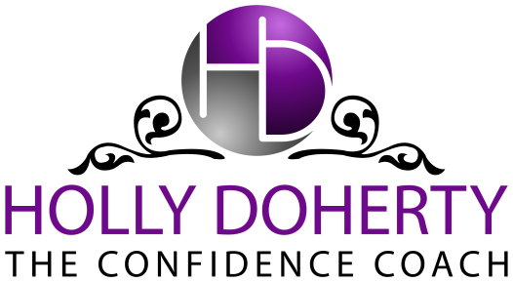

www.hollydoherty.com
Testimonials
“I was really moved by your presentation. I admire your strength. Thank you for coming forward and showing such beauty inside and out. I am empowered by you and I thank you from the bottom of my heart.” - Angel T.
“Your talk sparked the best discussions we’ve had all year.” - Linda M.
“At first, I really had my guard up. But the more you spoke, the more my heart melted. Thank you for sharing your story and helping me realize I’m not alone.” - Jessica W.
“The more I learn about you, the more amazing I think you are.... I also realize what a strong person you are. Your story is truly a testament to leaning on God through some incredibly hard times. Your positive spirit and your willingness to reflect on what you've experienced is truly a gift to other women. It was a presentation that will really stick with a lot of people.” - Molly D.
“Thank you for speaking to our group. Your passion for women and your love of Christ is very apparent. I know the women benefited from you speaking to us.” - Amy C.
“Thank you for your transparency! Go has gifted you with many talents. It’s so beautiful to see you use them to edify His people and glorify Him.” - Jamie L.
“You truly are an inspiration to all. I will take the information you shared and truly remember it always. You do an excellent job and I see Jesus working in your life. Your light shines!!” - Joann R.

